Enroll Now School Year 2022-2023 | FIRST FLIGHT  North Point Early Childhood Training Program |  |  |  |  |  |  |  | Contact our director:  Lisa Willett  lwillett@ccboe.com
What is First Flight?  First Flight is a daily two-hour program for children ages 3-5 and is part of the licensed North Point Early Childhood Training Program.  This developmentally appropriate program provides a healthy, happy setting where children learn through play. The daily activities are planned to meet the individual and group needs of the children.  This program is staffed by early childhood professionals and the students in the Education Careers CTE Program at North Point High School. The Education Careers Program provides secondary students with real world experience working with young children. All teachers and high school students in the program meet the licensing requirements of CCPS and MSDE the Office of Childcare. |  |  |  | 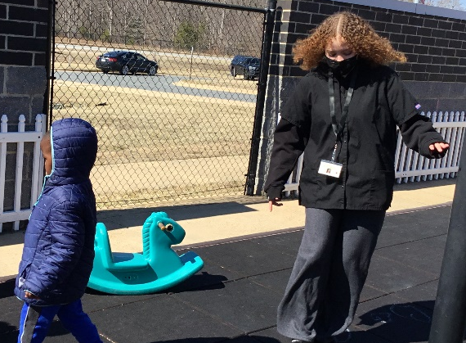  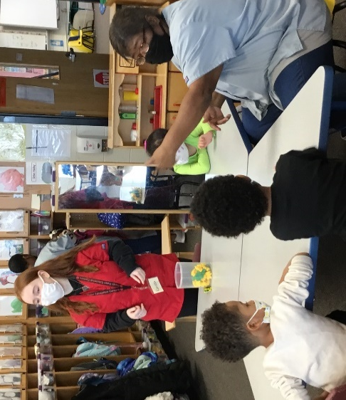  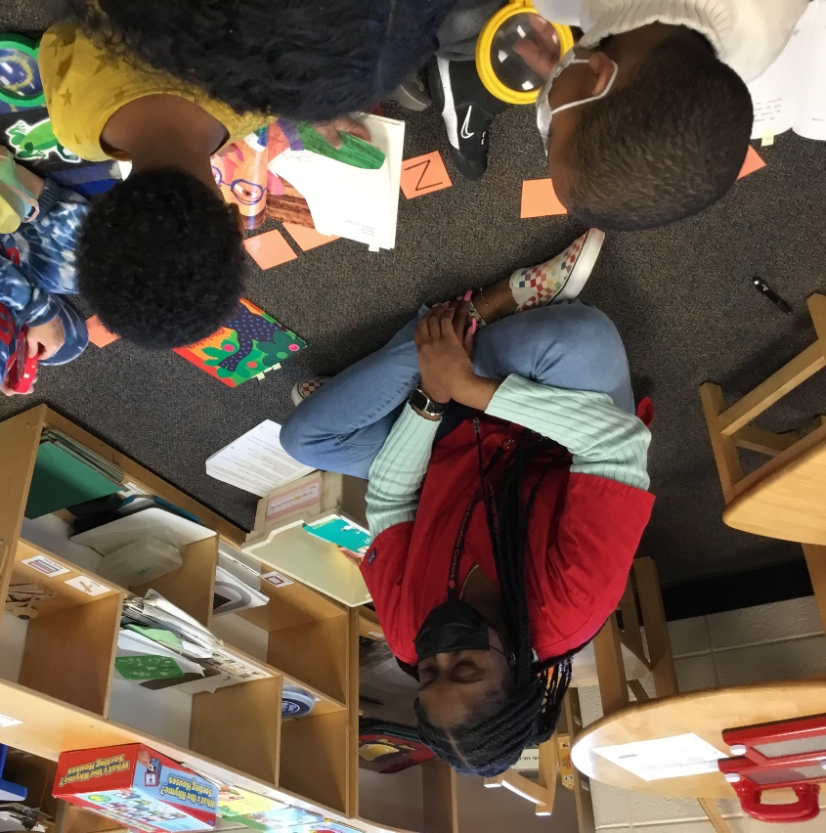
 |  |  |  | High School students in the Eduction Careers Program plan and implement lessons with the children (ages 3-5) in the First Flight Program.
 |  |  |  | Our Philosophy How Do I Apply?
 |  |  |  | We believe that children develop best when school and parents work together with the child’s best interest as the primary goal.  We believe that a center should be a very warm, loving, happy place with cheerful and positive attitudes.  We believe that children need years of play with real objects and events before understanding symbols.  We believe that children should have many opportunities daily to develop social skills such as helping, cooperating, negotiating, and talking with others.  We believe that outdoor experiences should be provided for all children.  We believe that good discipline or guidance is a learning experience for children. |  |  |  | Complete a  Contact Information Form  You can obtain a form by:  - Picking up a copy in the Main Office at North Point High School.  - Emailing the director to request a copy of the form.  - Downloading the form from our website.  How Do I Get More Information?  Visit our website: https://www.npectp.org/  Contact the director, Lisa Willett: lwillett@ccboe.com  *Tours can be scheduled on Wednesdays*
North Point Early Childhood
Training Progam
“Home of the Little Eagles”

Hours of Operation  First Flight runs each school year, October-April  4 Days a Week  (Closed on Wednesdays)  Morning Session:  8:15 a.m. - 10:15 a.m.  Afternoon Session:  12:00 p.m. - 2:00 p.m. |  |  | Eligibility and Fees  First Flight is open to children ages 3-5. A maximum of 20 children will be enrolled in each session. Spots are reserved through the payment of the holding fee.  Snack & Supply Fee:  $425.00 per year  Holding Fee:  $100.00  This amount will be applied to your payment for the year. |  |  |  | Location  North Point High School  2500 Davis Road  Waldorf, MD 20603  301-753-1759 ext. 159113

